AN EFFICIENT NOVEL APPROACH FOR PREDICTING STARTUP COMPANY SUCCESS RATES USING ADVANCED MACHINE LEARNING PARADIGMS
Methodology, Novelty and Key Contributions
Department of Computer Science and Engineering, [COLLEGE NAME]
Batch C10 (CSE-C) · Academic year [ACADEMIC YEAR]
Table 1: Project team
S.No. | Student name | Roll number
1 | Orchu Shirisha | 23K91A05H6
2 | Mudavath Raghavendar | 23K91A05G1
3 | Majgi Vaishnavi | 23K91A05E0
4 | Polishetty Poojitha | 23K91A05J4

Project guide: P Prasanna
Chapter and section numbers quoted in the text (for example Chapter 8 or Section 6.2) refer to the full project report, 17.Final Document. Figures and tables in this document are numbered from 1.

1. METHODOLOGY
This document describes how the startup outcome prediction system (VenturePulse) works from end to end and what is new in it. Part 1 gives the pipeline, the data, the algorithms and the reasons they were chosen; Part 2 sets the work against the base paper and separates what is new from what is standard; Part 3 lists the contributions.

1.1 Overall methodology
The method is a supervised classification pipeline on a mixed table of numbers, flags and categories, extended with a text channel and an evidence channel. A startup is described by nine numeric fields (funding total and rounds, ages at the first and last funding and milestone, relationships, milestones and average participants), seven flags (venture capital, angel investors, rounds A to D and a top-500 mark), a state, an industry and, optionally, a short business description. The structured part is imputed, scaled and one-hot encoded into 37 values. The description is turned into a 384-value sentence embedding by all-MiniLM-L6-v2 [25, 26]. The two blocks are fused into one unit-length vector that is used twice: by the classifier, which gives the probability of SUCCESS, and by a nearest-neighbour search over the training startups, which gives comparable historical cases in the spirit of the retrieval idea of [2] and the classical nearest-neighbour rule [30]. The steps are:
1. Load a startup table: a local CSV of the public Kaggle table if present, otherwise the built-in synthetic generator with the same columns.
2. Prepare: remove duplicate rows, map the status to a label (acquired and IPO to SUCCESS, closed to FAILURE), coerce numbers, normalise categories and add the logarithm of the funding total.
3. Encode: median imputation and standardisation of the numbers, most-frequent imputation of the flags, one-hot encoding of state and industry, giving 37 structured values.
4. Embed the description (company names masked, at most 2,000 characters) with MiniLM and fuse it with the structured vector with weight 0.5 each.
5. Compare Logistic Regression, Decision Tree, Random Forest and XGBoost on five repeated stratified 80/20 splits, with the preprocessor fitted on the training part only.
6. Select the model with the highest mean balanced accuracy, refit it on all rows and store it with the preprocessor and the fused training vectors.
7. Serve: for a submitted startup compute the probability of SUCCESS, retrieve k comparable startups with an equal quota of each outcome, and return an explanation and a risk label.
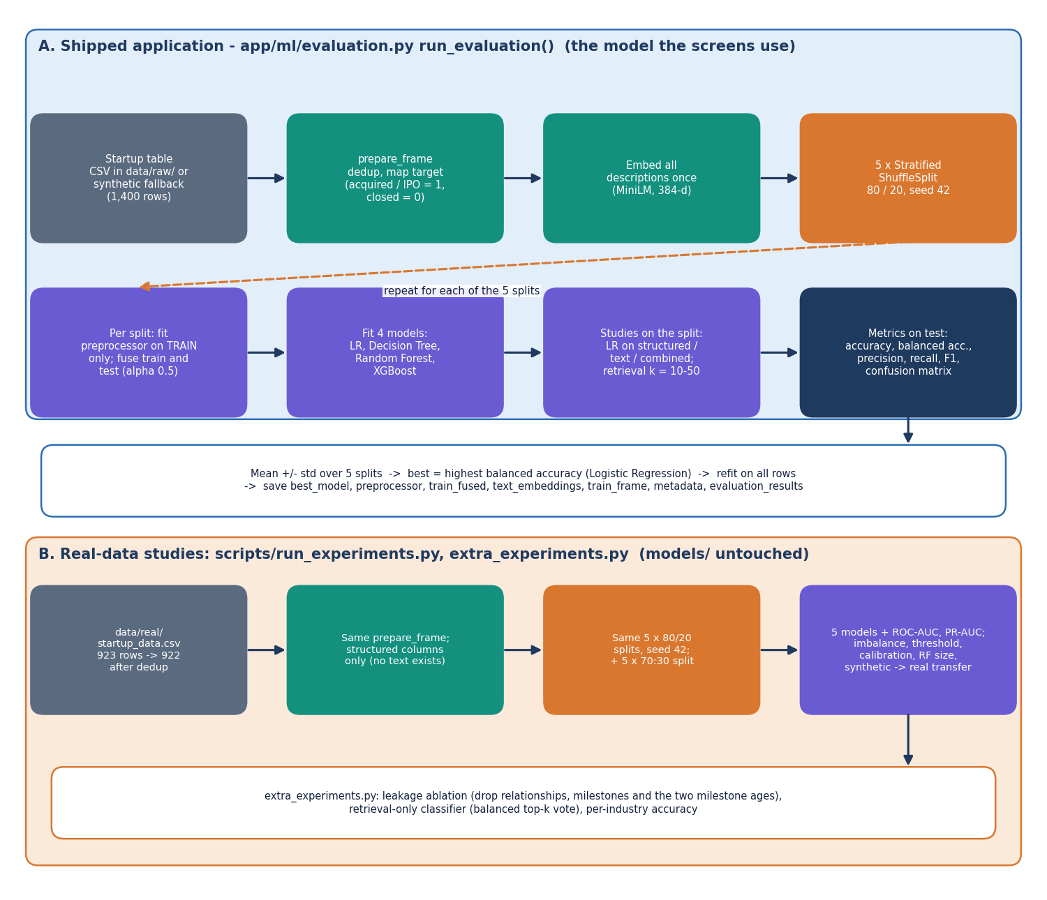
Figure 1: Evaluation protocol used for model selection and for the reported metrics.
Two sets of measurements. The shipped application was trained on the synthetic fallback table, so the statistics it displays (Logistic Regression 0.749 balanced accuracy) test whether the pipeline recovers a signal that the generator planted. For real evidence the same code (app.ml.preprocessing, app.ml.models and the same split protocol) was run by scripts/run_experiments.py and scripts/extra_experiments.py on the real public table of 922 startups, structured features only, in 139 s on the CPU. Those runs add ROC-AUC and PR-AUC, a fifth model (HistGradientBoosting), two imbalance strategies, a decision-threshold sweep, calibration bins, a forest-size study, the 70:30 protocol of the base paper, a synthetic-to-real transfer test, a leakage ablation and a retrieval-only classifier. Chapter 8 reports them; this chapter describes how they were made.

1.2 Dataset

1.2.1 The public Startup Success Prediction table (all real measurements)
The real data is the public "Startup Success Prediction" table of [32] (listed as public domain): 923 start-ups, 49 columns, almost all in the United States. The outcome column status is acquired for 597 companies and closed for 326. The Kaggle download requires a login, so the identical 923-row CSV was fetched from a public GitHub copy into data/real/startup_data.csv; it was deliberately kept out of data/raw/ so that the shipped application is not changed. The application's own de-duplication leaves 922 rows, 596 SUCCESS (64.6 %) and 326 FAILURE. Success is therefore the majority class, the reverse of the situation assumed in the project objectives. The table has 9 numeric columns, 7 flags, a state code and an industry category code that the script maps to the ten industry names of the application (software, e-commerce, mobile, media, biotech, health technology, clean technology, education; anything else becomes Other); states outside the ten most common become Other. The table has no free-text description, so the text and retrieval channels cannot be evaluated on it.
Three of the numeric columns (relationships, milestones and the two milestone ages) are recorded at or after the end of the observation window for part of the companies, and the table has no time stamps with which to remove them. They are kept for the main results and removed in a separate ablation (Chapter 8); this is the look-ahead problem that the base paper itself cites [9, 29].

1.2.2 The synthetic fallback table (the shipped application)
If no CSV is found the loader calls generate_synthetic (seed 42), which creates 1,400 rows with the same columns: 595 SUCCESS and 805 FAILURE (the success probability of a row is 0.42). Every numeric field is drawn from a distribution whose parameters differ slightly by class (for example, successful companies get a larger mean number of rounds, milestones and relationships, and a higher chance of venture capital and later rounds). The description is built from one of nine templates: with probability 0.35 a template shared by both classes, with 0.45 a template that matches the class, and with 0.20 a template of the other class. The wording of the text therefore depends on the label by construction. The signal in this table is the one the generator planted, so a model that scores well on it shows that the pipeline recovers a planted signal, not that startups can be predicted this well. The fallback is recorded in the metadata (synthetic_fallback: true), in data/raw/SYNTHETIC_FALLBACK.txt and in the dataset note shown on the dashboard.
Table 2: The two data sources
 | Real public table | Synthetic fallback
Rows used | 922 (596 SUCCESS, 326 FAILURE) | 1,400 (595 SUCCESS, 805 FAILURE)
Share of SUCCESS | 64.6 % (majority class) | 42.5 % (minority class)
Description text | None | Template sentences, wording depends on the label
Used for | All real measurements (structured features only) | The shipped model, the dashboard, the screenshots, the representation and retrieval-size studies
Origin | Public Kaggle table, copy from a public GitHub repository | generate_synthetic, seed 42
Evaluation | 5 x 80/20 stratified splits, seed 42 (185 test rows per split) | The same protocol (280 test rows per split)

1.3 Preprocessing and feature construction

1.3.1 Cleaning and the target
prepare_frame removes duplicate rows, maps status to the label (acquired, success, IPO, true, yes and 1 to SUCCESS = 1; closed, failure, no and 0 to FAILURE = 0; any other value is dropped), converts the numeric and flag columns with to_numeric (bad values become missing), strips and normalises the state and industry strings (missing becomes Unknown), adds the column log_funding_total_usd = log(1 + funding) to reduce the heavy tail of funding amounts, and cleans the description. No outlier removal is done.

1.3.2 Structured preprocessor
Table 3: The 37 structured features
Group | Fields | Treatment | Columns
Numeric | age_first_funding_year, age_last_funding_year, age_first_milestone_year, age_last_milestone_year, relationships, funding_rounds, funding_total_usd, milestones, avg_participants, log_funding_total_usd | Median imputation, standardisation | 10
Flags | has_VC, has_angel, has_roundA, has_roundB, has_roundC, has_roundD, is_top500 | Most-frequent imputation | 7
State | CA, CO, FL, IL, MA, NY, OR, PA, TX, WA (and Other when present) | Constant imputation (Unknown), one-hot, unknown categories ignored | 10
Industry | AI, Biotech, CleanTech, E-Commerce, EdTech, FinTech, HealthTech, Media, Mobile, Software (and Other when present) | Same as state | 10

The preprocessor is a scikit-learn ColumnTransformer that is fitted on the training part of every split, so no test statistic reaches the scaler or the imputers. The 37 columns are the same for the shipped table and for the real table fitted on all 922 rows.

1.3.3 Text cleaning and embedding
The description is cleaned by clean_text: a regular expression replaces a capitalised company name followed by Inc, LLC, Labs, Technologies or Systems with "this company", whitespace is collapsed and the text is cut at 2,000 characters. Masking names follows the practice of [2], which prevents a language model from recognising a famous company. The text is embedded by sentence-transformers/all-MiniLM-L6-v2, a 22-million-parameter model that gives a 384-value vector per text on a CPU. If the model cannot be loaded, a deterministic hashing embedding of the same size is used and the backend name (sentence-transformers or hash-fallback) is returned in every result. An empty description is replaced by the text "<industry> startup".

1.3.4 Fusion
Each block is scaled to unit length and the fused vector is [0.5 s, 0.5 t], scaled to unit length again (equation in Section 6.5). The weight alpha = 0.5 is a fixed constant in app/config.py; it was not tuned.

1.3.5 Class imbalance
All classifiers are trained with balanced class weights (class_weight="balanced" for Logistic Regression, Decision Tree and Random Forest). XGBoost is used with its default class handling, and the retrieval step enforces equal quotas. The base paper oversamples with ADASYN [24]; oversampling by random duplication of the minority rows was compared with class weights on the real table (Chapter 8, where the minority class is FAILURE). SMOTE-type synthetic oversampling [23] was not implemented.

1.4 Algorithm choice and justification
Table 4: Algorithms and why they are used
Component | Choice | Reason
Baseline classifier | Logistic Regression | Transparent, fast, signed coefficients give the explanation, and it is the baseline of the base paper [1] and of [2]
Single tree | Decision Tree (depth 8) | Readable rules; high variance, so it shows what ensembling improves
Bagged ensemble | Random Forest (300 trees) [18] | Handles mixed variables and interactions with little tuning; named best model of the base paper
Boosted ensemble | XGBoost [19]; HistGradientBoosting in the real-data study | The boosting family of the objectives (gradient boosting [20]); a second boosting implementation checks that the result is not specific to XGBoost
Text representation | all-MiniLM-L6-v2 sentence embeddings | Small, runs on a CPU, no key or service; captures meaning beyond keywords; used by the base-paper family for startup descriptions
Fusion | Weighted concatenation, unit length | One vector serves the classifier and the search; cosine similarity becomes a dot product
Evidence | Balanced top-k cosine retrieval | Shows comparable startups of both outcomes; retrieval was the idea of [2]; fixes the evidence view when classes are imbalanced
Selection metric | Balanced accuracy | Insensitive to class ratio; the primary metric of [2]
Explanation | Coefficients or importances plus retrieval counts | Deterministic, no sampling, no extra library; SHAP [33] was not used

Support vector machines and gradient boosting are named in the base paper; an SVM was not implemented here because Logistic Regression already serves as the linear baseline and the objectives name Logistic Regression, Decision Tree, Random Forest and boosting ensembles. Deep networks were excluded: with 922 or 1,400 rows they would overfit and could not be tuned reliably, a point made in [2] for few-shot settings.

1.5 Mathematical formulation

1.5.1 Standardisation and the logistic model
Each numeric column is standardised with the training mean and standard deviation. Logistic Regression models the probability of SUCCESS as a sigmoid of a linear score and is fitted by minimising the class-weighted log-loss with an L2 penalty (C = 1):
z = (x - mean) / sd P(y = 1 | x) = 1 / (1 + exp(-(w . x + b))) (1)
minimise sum_i c(y_i) * [ -y_i log p_i - (1 - y_i) log(1 - p_i) ] + (1 / 2C) ||w||^2, c(y) = n / (2 n_y) (2)

1.5.2 Trees and ensembles
A tree chooses splits that reduce the Gini impurity of the child nodes. A Random Forest averages the votes of many trees grown on bootstrap samples with random feature subsets; its Gini importance is the total impurity decrease of a feature, and its permutation importance is the drop in the test ROC-AUC when one feature is shuffled. XGBoost adds trees one by one, each fitted to the gradient of the regularised objective:
G = 1 - sum_c p_c^2 y_hat(x) = sum_k f_k(x) Obj = sum_i l(y_i, y_hat_i) + sum_k [ gamma T_k + (lambda / 2) ||w_k||^2 ] (3)

1.5.3 Fused vector, cosine similarity and the retrieval vote
With s the structured vector and t the text embedding, both scaled to unit length, and alpha = 0.5, the fused vector and the similarity of two startups are
x = [ alpha s , (1 - alpha) t ] / || [ alpha s , (1 - alpha) t ] || sim(x, x') = x . x' (4)
For a submitted startup the training rows are ranked by similarity and the first k//2 SUCCESS rows and k - k//2 FAILURE rows are kept (the set N_k). The similarity-weighted vote used in the retrieval-size study and in the retrieval-only classifier is
p_vote = sum_{i in N_k} max(0, sim_i) * y_i / sum_{i in N_k} max(0, sim_i) predict SUCCESS if p_vote >= 0.5 (5)

1.5.4 Decision rule and risk label
outcome = SUCCESS if P(y = 1 | x) >= 0.5 else FAILURE confidence = max(P(y = 1), P(y = 0)) (6)
The risk label is "Lower risk" if the outcome is SUCCESS and the confidence is at least 0.70, "Moderate risk" if the confidence is at least 0.55, and "Higher uncertainty" otherwise. The threshold of 0.5 is the default; Chapter 8 shows what other thresholds would do on the real data.

1.5.5 Metrics
With TP, FP, TN and FN counted for SUCCESS as the positive class:
accuracy = (TP + TN) / n precision = TP / (TP + FP) recall = TP / (TP + FN) F1 = 2 P R / (P + R) (7)
balanced accuracy = (1/2) [ TP / (TP + FN) + TN / (TN + FP) ] (8)
ROC-AUC = P( score of a random SUCCESS > score of a random FAILURE ) = integral of TPR d(FPR) (9)
Balanced accuracy is the selection metric because it does not reward predicting the majority class. ROC-AUC [28] measures ranking quality independently of the threshold; PR-AUC [27] is stored beside it in the real-data results. Every value is the mean and the standard deviation over five splits.

1.6 Model architecture and training configuration

1.6.1 Hyper-parameters
Table 5: Classifiers and their exact settings (app/ml/models.py)
Model | Settings
Logistic Regression | solver lbfgs, class_weight balanced, max_iter 1000, C 1.0
Decision Tree | max_depth 8, min_samples_split 10, min_samples_leaf 5, class_weight balanced, random_state 42
Random Forest | n_estimators 300, class_weight balanced, min_samples_leaf 2, n_jobs -1, random_state 42
XGBoost | n_estimators 400, max_depth 6, learning_rate 0.05, subsample 0.8, colsample_bytree 0.8, reg_lambda 1.0, eval_metric logloss, random_state 42 (a scikit-learn HistGradientBoosting with the same depth and rate is the code's fallback)
HistGradientBoosting (real-data study only) | max_iter 300, max_depth 4, learning_rate 0.05, l2_regularization 1.0, random_state 42

Table 6: Constants (app/config.py)
Constant | Value | Meaning
RANDOM_STATE | 42 | Seed of the splits and the tree models
N_SPLITS / TEST_SIZE | 5 / 0.2 | Five stratified shuffle splits, 20 % test
ALPHA | 0.5 | Weight of the structured block in the fused vector
EMBEDDING_MODEL_NAME / EMBEDDING_DIM | all-MiniLM-L6-v2 / 384 | Text encoder and its output size
DEFAULT_K / RETRIEVAL_KS | 50 / [10, 20, 30, 50] | Number of comparable startups and the values the API accepts
MAX_DESC_LEN | 2,000 | Longest accepted description (characters)

1.6.2 Training and selection
run_evaluation embeds all descriptions once, runs the five splits and fits the four models on the fused vectors of each split. It also fits Logistic Regression on structured-only, text-only and combined vectors and scores the similarity-weighted vote for each k. The model with the highest mean balanced accuracy is refitted on all 1,400 rows. On the shipped table that is Logistic Regression (0.749 ± 0.025), ahead of XGBoost (0.697 ± 0.010), Random Forest (0.641 ± 0.021) and Decision Tree (0.614 ± 0.041). On the real table the order differs: XGBoost and Random Forest reach 0.746 ± 0.026 and 0.746 ± 0.031, and Logistic Regression 0.709 ± 0.025 (Chapter 8). The served model was therefore selected on synthetic data, and rebuilding the artefacts from a real CSV can select a different model without any code change.

1.6.3 Cost of training
All studies were run on Intel Core i5-12500 (6 cores, 12 threads), 15.7 GB RAM, Windows 11 Pro, CPU only (no GPU). The whole real-data study (five models, five splits, imbalance, threshold, calibration, size and transfer studies and permutation importance) took 139 s, and the extra studies 13.7 s. Training the shipped models on 1,400 rows with embeddings, five splits and charts takes a few minutes the first time, mostly for downloading and running the embedding model; later starts load the stored artefacts in seconds.

2. NOVELTY AGAINST THE BASE PAPER
The project does not propose a new learning algorithm and does not claim one. Logistic regression, decision trees, random forests and gradient boosting are established methods [18, 19, 20, 21], and so is retrieval of nearest neighbours by cosine similarity [30]. What the project contributes is a particular combination of a classifier with retrieved comparable startups and feature-level reasons, the packaging of that combination as a local application, and a measurement of how well it works on a real public table. This document states first how the work differs from the declared base paper and the method anchor, then what is and is not new, and finally what the evidence supports.

2.1 Difference from the base paper and the method anchor
Table 7: The base paper, the method anchor and this project compared
Dimension | Base paper (Panjwani et al. 2026) [1] | Method anchor (Maarouf et al. 2026) [2] | This project
Problem | Startup success classification | Startup success with an LLM and retrieved examples | Startup outcome (SUCCESS / FAILURE) with comparable-startup evidence
Data | Crunchbase / Kaggle data; size not stated | 4,034 Crunchbase startups, 35.15 % successful | Real public table: 922 rows (structured only); shipped app: 1,400-row synthetic fallback with text
Features | Funding, team size, industry, location | Structured profile plus text description | 16 structured fields, state and industry (37 encoded features) plus a 384-d description embedding
Learner | LR, RF, SVM, Gradient Boosting | kNN in-context learning with an LLM, against LR, RF, XGBoost | LR, Decision Tree, RF, XGBoost (HistGradientBoosting in the study); balanced cosine retrieval beside the classifier
Imbalance | ADASYN oversampling | Balanced accuracy as metric | Balanced class weights; oversampling compared on real data; balanced accuracy as the selection metric
Protocol | Single 70:30 split | 5 repeated stratified 80/20 splits | 5 repeated stratified 80/20 splits (and a 70:30 x 5 seeds run for comparison)
Explanation | Feature importance chart | LLM reasoning | Signed top-5 feature terms, retrieval statistics and the retrieved startups themselves
Delivery | Flask page | Experiment code | FastAPI + React application, local only, no external model service

2.2 What is new and what is not
Table 8: Elements of the work and their status
Element | Status | Note
LR, Decision Tree, Random Forest, XGBoost and their metrics | Standard | Used through scikit-learn and XGBoost [21, 19]; the ensemble ranking is the one the base paper reports
Class weighting and oversampling for imbalance | Standard | Established remedies [22, 23, 24]; compared here on real data
Retrieval of the most similar past startups as evidence | Adapted idea | The retrieval-of-comparable-startups idea and the 5 x 80/20 protocol follow [2]; here the LLM is replaced by a classifier and the retrieved cases are shown as evidence
Fusion of scaled structured features with a sentence embedding by a weighted concatenation (alpha = 0.5) and L2 normalisation | Design choice of this project | MiniLM embedding [26, 25]; a single cosine similarity then covers both views
Balanced half-success / half-failure retrieval quota from training rows only | Design choice of this project | Stops the neighbours of a rare outcome from being swamped, and cannot see test rows (no leakage)
Application returning verdict, probabilities, drivers and comparable startups | New in this project | Six React screens, the original Jinja pages, eleven JSON routes, demo sign-in
Ten-study real-data benchmark including a leakage-like-feature ablation and a retrieval-only classifier | New in this project | Separates what the models learn from what the table leaks and from what the text adds
Observations: 85-92 % not reproduced; ROC-AUC falls by about 0.1 without post-hoc fields; retrieval alone equals LR; synthetic text leaks the label | Findings of this project | Reported with the data that supports them

2.3 What the evidence supports
The evidence supports the statement that the combination works end to end and that, on the real structured table, the tree ensembles rank above logistic regression, as the base paper claims: balanced accuracy 0.746 (Random Forest) and 0.746 (XGBoost) against 0.709 (Logistic Regression), ROC-AUC 0.816, 0.806 and 0.789. It does not support the 85-92 % accuracy level of the base paper (best accuracy 0.775 on 80/20 splits and 0.796 on a 70:30 split). It does not support a claim that the text embedding helps on real startups, because the real table has no descriptions; on the synthetic table the combined view scores 0.749 against 0.714 for the structured view, but that synthetic text was generated from class-specific templates and leaks the label. A retrieval-only classifier on the real structured features reaches balanced accuracy 0.714 to 0.703, equal to logistic regression. These are limits of the present experiment (one 922-row table, five splits, 185-row test folds) and are discussed under limitations.

3. KEY CONTRIBUTIONS
1. An end-to-end startup-outcome application, VenturePulse: a FastAPI backend and a React interface that take 16 structured fields, a state, an industry and an optional description, and return a SUCCESS / FAILURE estimate with probabilities, a risk label, the main feature drivers and the comparable historical startups, all computed locally.
2. A fused structured-plus-text representation (scaled features and a 384-dimensional MiniLM embedding, weight alpha = 0.5, L2 normalised) with a balanced, training-only cosine retrieval of k = 10, 20, 30 or 50 comparable startups, adapted from the retrieval idea of the method anchor without a language model.
3. A comparison of Logistic Regression, Decision Tree, Random Forest and XGBoost under five repeated stratified 80/20 splits with balanced accuracy as the selection metric, plus HistGradientBoosting on real data, class-imbalance strategies, a threshold sweep, calibration bins and a Random Forest size study (scripts/run_experiments.py).
4. A set of honest findings on the real table: tree ensembles beat logistic regression (balanced accuracy 0.746 against 0.709) but not to the 85-92 % level of the base paper; removing four post-hoc fields lowers ROC-AUC from about 0.816 to 0.719; retrieval alone equals logistic regression; the shipped synthetic text leaks the label.
5. A test and measurement record: 51 automated checks (7 unit tests, 15 smoke checks, 29 API edge cases) and a measured response time of 148 ms (k = 10) to 198 ms (k = 50) per prediction on a CPU-only machine.

